- Resample population
  - Do this by using Warp in QGIS
    - Select the raster as Input layer
    - Select the Source CRS as EPSG:4326
    - Select the Target CRS as EPSG:3395, this would later when we do the resample allow us to use 1000 directly in Output file resolution
    - Type 0 in the field that says Nodata value for output bands
    - Type 1000 in the field that says Output file resolution in target georeferenced units
    - In the field that says Additional command-line parameters type exactly:
-r sum -tap
- tap ensures that there is no shift in cells
- r sum overrides the option in Resampling method to use (sum does not exist)
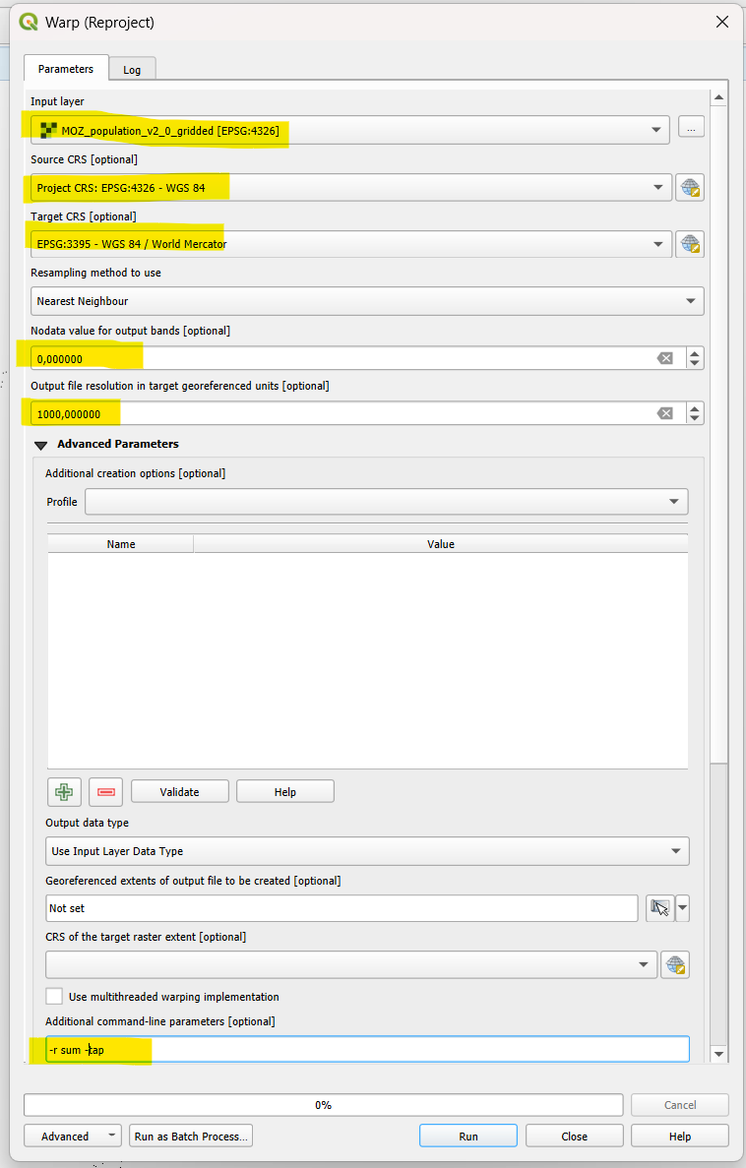
- Polygonize
  - Use the tool named Raster pixels to polygons. The other tool (Polygonize (raster to vector))I rounds all values and connects population cells that are rounded to the same integer (which leads to polygons of different sizes).
- Load the clusters
- Reproject the clusters to EPSG:3395
- Save the polygons and clusters
  - Save the clusters and polygons from step two as .gpkg
- Spatial index
  - Once the clusters and polygons are saved they will appear in QGIS
  - Create a spatial index for both layers
- Select by location
  - Select polygons from the population grid based on how they are overlapping with clusters
- Remove non overlapping polygons from population grid
  - Switch the selection, start editing, remove selected and save edits
- Load result file into QGIS
- Join the result file with the clusters
  - I take MinimumOverallLCOE2030, FinalElecCode2030 and IsUrban
- Rasterize columns from step 10
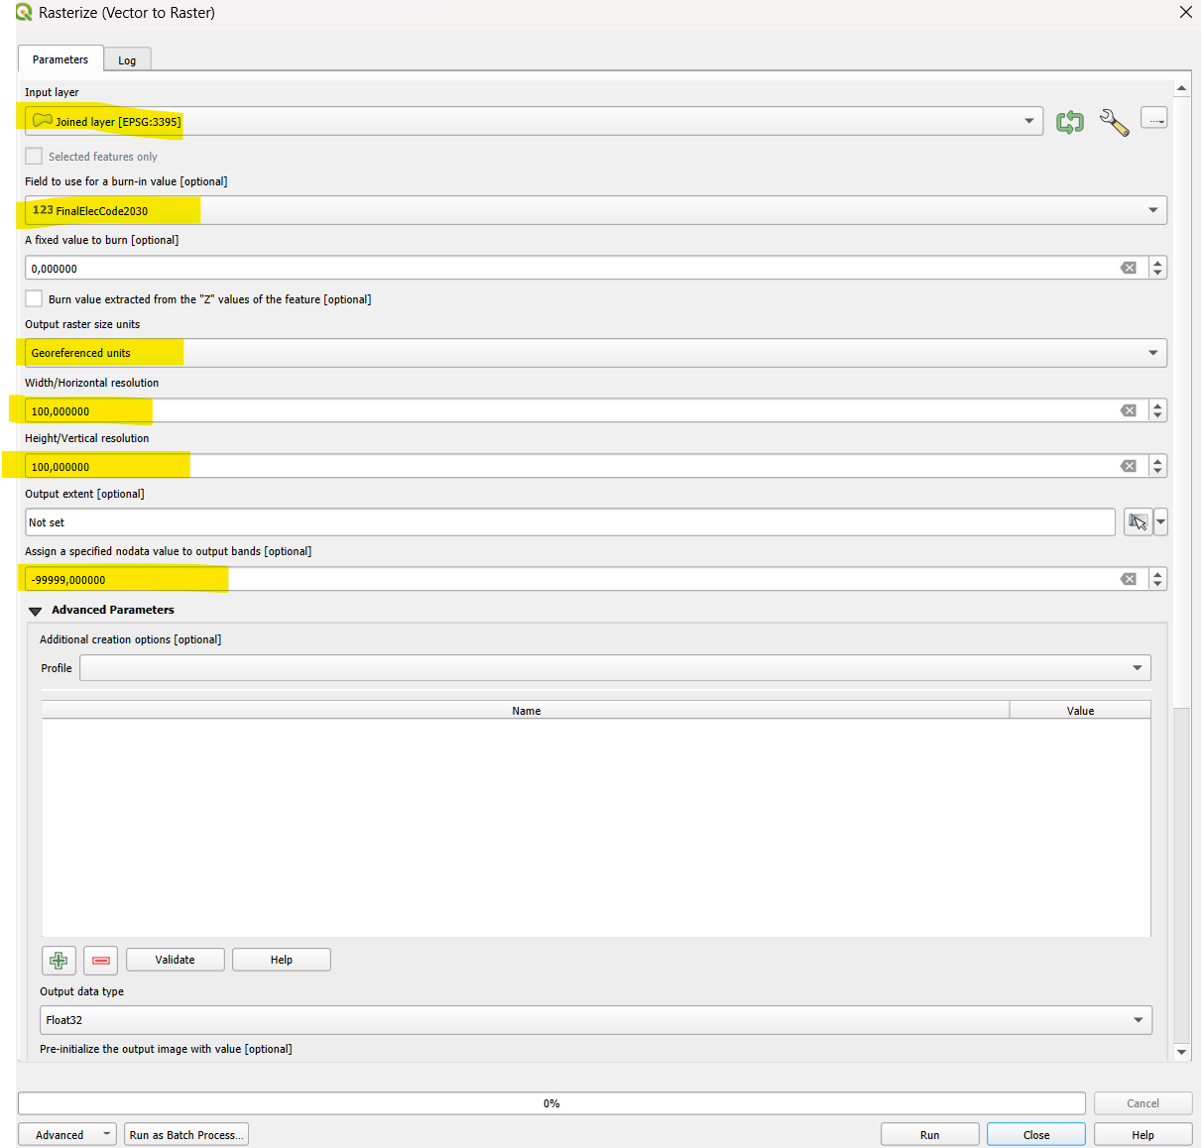
- Zonal statistics between rasters from step 11 and polygons from step 8
- Rasterize zonal statistics results
